Updates
Home Page
#1
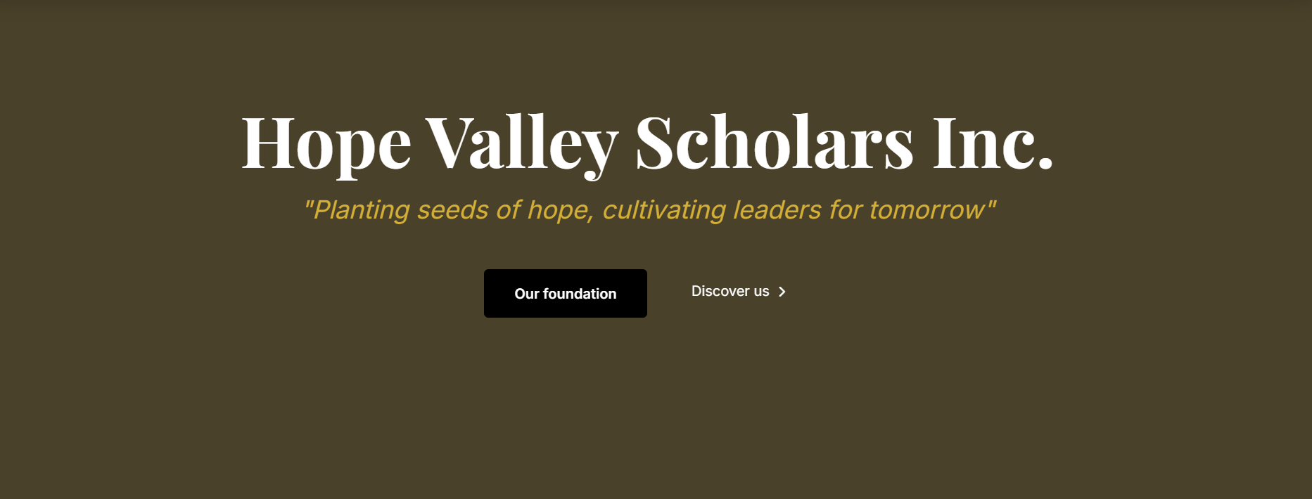
On the home page, let me know if you are able to use this photo as a background so that this rim does not look so plain

#2
Why we exist…..
Keep this as is for the wording and remove the photo next to it.
#3
Our impact Pillars
Keep this as is no changes needed.
#3
Remove the four education pathways, the core values from the home page since they are on the programs page to avoid repetitiveness.
#4
The education excellence part. This is okay, no changes needed
#5
Upcoming events……hide this from the page. It can be made visible when there is an event.

About Page
#1

Remove this part and go straight to Our Story, Our Mission, Our Vision
Our Story
The vision began with a simple but profound experience: seeing brilliant young students unable to continue school because of financial limitations. Their dreams were bright, their effort unmatched, but opportunity was out of reach. Hope Valley Scholars exists to rewrite that narrative one student, one family, one community at a time.
Hope Valley Scholars Inc is a nonprofit organization dedicated to supporting academically gifted, financially disadvantaged students in Kenya from high school through university. We walk alongside our scholars with education support, mentorship with purpose, and marketplace preparation helping them grow into confident leaders who give back, build strong families, strengthen institutions, and transform communities.
Our Mission
Hope Valley Scholars Inc supports academically gifted and financially disadvantaged students in Kenya from high school through university by providing access to education, mentorship, leadership development, and career readiness. Our mission is not only to expand access to education, but to cultivate value-driven leaders who give back, drive positive change, and build resilient communities.

Our Vision
We envision a future where talented students rise from education to leadership, transforming families, strengthening institutions, and shaping ethical marketplaces across generations. Through long-term mentorship, leadership training, and professional readiness, Hope Valley Scholars Inc contributes to developing a generation of leaders committed to service, integrity, and community transformation.

Remove this image….


#2
Remove the quote below and replace it with the following…..
The philosophy of the school room in one generation will be the philosophy of government in the next."
Abraham Lincoln


#3
Core values section. This is good. No changes needed

Programs Page
#1
Under our programs replace what you have currently (h=screenshot) the following with this verbiage noted below
Empowering students through education support, mentorship with purpose, and leadership development that prepares them for lifelong success and meaningful community impact.
#2
Under “Our Impact Pillars” update as follows
At Hope Valley Scholars Inc, our programs go beyond financial assistance. We provide a structured pathway that supports students from high school through university, equipping them with education, mentorship, leadership formation, and professional readiness to become confident leaders who give back.
#3
Under the “Give-Back & Community” pillar, replace the image you have currently with the one below.

Impact Page
The only thing needed is to remove this image



Get involved Page
This looks great only one slight suggestion
For the button below, let it link up to a separate page for donations. Please see suggestions below. Let me know if this is possible. I am working on the bank details and will update as soon by next week.


Additional Page Name
Sponsor a Student. Transform a Future.
Opening Message
Hope Valley Scholars Inc supports academically gifted and financially disadvantaged students in Kenya by providing education access, mentorship, and leadership development from high school through university.
Your generosity removes financial barriers and creates a pathway to confidence, purpose, and lifelong impact.
Sponsorship Options
$1,000 — Sponsor One Academic Year
Covers tuition, school supplies, mentorship, and academic support.
$3,000 — Sponsor the Full High School Journey
Provides three years of continuous education, mentorship, and leadership formation.
Monthly Sponsorship
- $85/month — One academic year
- $250/month — Full high school journey
Custom Gift
Support any portion of a student’s education.
“I will send you the donation link to add here”
**All donations are securely processed and deposited directly into Hope Valley Scholars Inc accounts. Sponsors receive periodic updates demonstrating student progress and impact.
Add this as well
Header
Give by Check
Message
If you prefer to donate by check, we gratefully accept contributions made payable to Hope Valley Scholars Inc. Check donations are a meaningful way to support student sponsorship and are especially helpful for churches, organizations, and major gifts.

Make Checks Payable To
Hope Valley Scholars Inc
Mailing Address
Hope Valley Scholars Inc
12 Calvarese Dr,
Bear, DE 19701

Important Note
Please include your email address or contact information so we can acknowledge your gift and provide sponsorship updates.

Contact Button
Button: Notify Us of Your Check
This can open your contact form.

Add the Automatic Sponsor Email once someone donates
Subject: Thank You for Sponsoring a Future Leader
Dear Sponsor,
Thank you for partnering with Hope Valley Scholars Inc. Your generosity is creating access to education, mentorship, and leadership development for students who might otherwise be unable to continue their education.
You will receive updates that demonstrate the impact of your support.
With gratitude,
Hope Valley Scholars Inc
Board Page
Change the font color for the below to the Yellow/orange (as you have on the board of directors) so as to stand out. I like that color.

Add this intro beneath the “Board & Governance”.
Hope Valley Scholars Inc is governed by a dedicated Board of Directors responsible for strategic guidance, fiduciary oversight, and mission alignment. Our board brings diverse professional expertise and a shared commitment to educational equity, mentorship, and community transformation.
**Governance commitment remains the same – no update needed**

For the board members, the bio and photos will come up soon but add this intro as well in the meantime.
Dr. Joan Githua
Founder & Board Chair
Provides strategic leadership and vision for the organization, ensuring mission alignment, growth, and strong partnerships that expand opportunities for scholars.

Dr. John Kathuri
Vice Chair
Supports governance and strategic planning while contributing insight into leadership development and long-term organizational sustainability.

Melchizedek Bosire
Treasurer
Oversees financial stewardship, budgeting, and accountability, ensuring responsible management of resources entrusted to the organization.

Lucy Kimani
Secretary
Maintains governance records, board coordination, and organizational compliance to support effective and transparent operations.

Martin Muya
Director at Large
Provides advisory support and strategic input to strengthen programs, partnerships, and community engagement.

Add buttons or icons for the following. (I have attached the policies)
Privacy Policy | Terms of Use | Donation Refund Policy | Child Safeguarding Policy | Mentor Code of Conduct | Volunteer Agreement | Photo Media Consent Form | Annual Report | Contact form

Contact Page
#1
Remove the map
#2
Edit the following contact form and add another one for student application

Headline:
We’d Love to Hear From You
Subtext:
Whether you’re interested in sponsoring a student, partnering with us, volunteering, or learning more, we welcome your message.

Contact Form Section
Form Fields
- Full Name
- Email Address
- Phone (optional)
- Organization / Church (optional)
- Subject (dropdown)
Dropdown Options:
- Sponsorship Inquiry
- Partnership Opportunity
- Volunteer Interest
- Student Application Question
- General Inquiry
Message Box
Button:
Send Message

Add this for student inquiry
Student Inquiry Section
Header
Student Inquiry & Scholarship Interest
Intro Text
We are honored that you are interested in becoming a Hope Valley Scholar. Our program supports academically gifted and financially disadvantaged students in Kenya from high school through university through education assistance, mentorship, and leadership development.
Please complete the form below to express your interest. Our team will review inquiries and provide guidance on the application process.

Student Inquiry Form Fields
Student Information
- Student Full Name
- School Name
- County / Location in Kenya
- Current Grade / Class / School
Academic Background
- KJSEA/KCSE academic results
- Favorite subjects
Family & Need
- Brief description of financial need
- Parent/guardian contact information
Personal Statement
- Why do you want to join Hope Valley Scholars? (250 words)

Button
Submit Inquiry

